HW06

Stav Rones

4/06/2020

1. **A)**

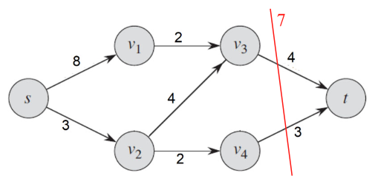

**B)**

1. 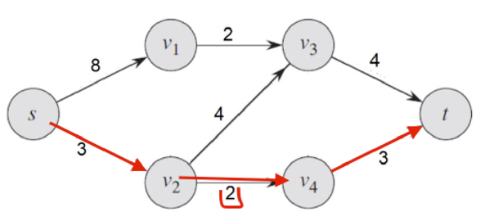
2. 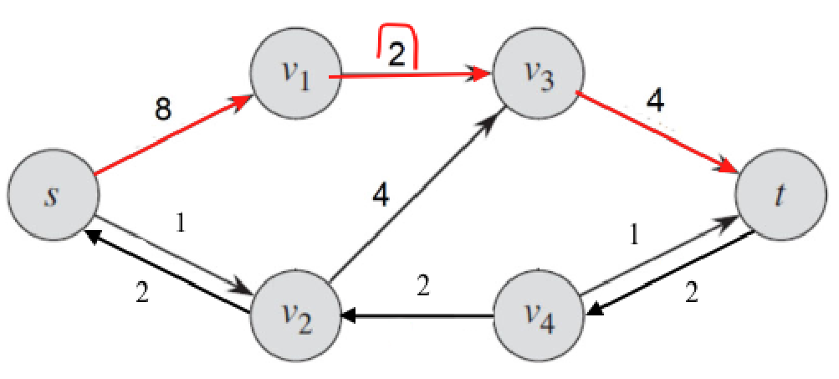
3. 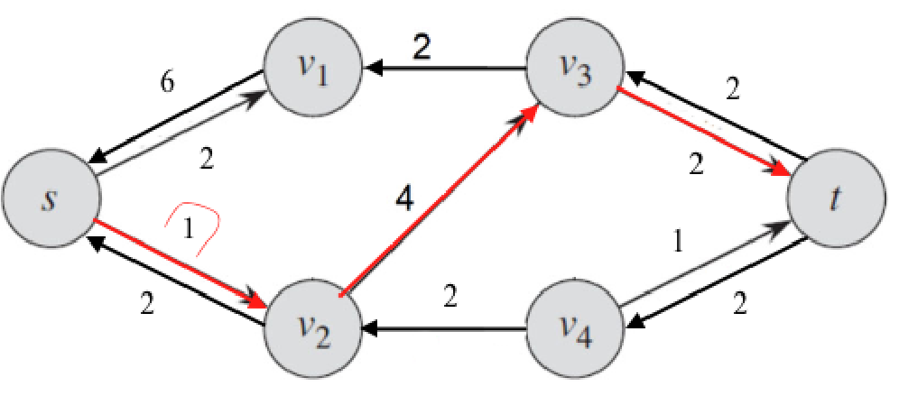
4. 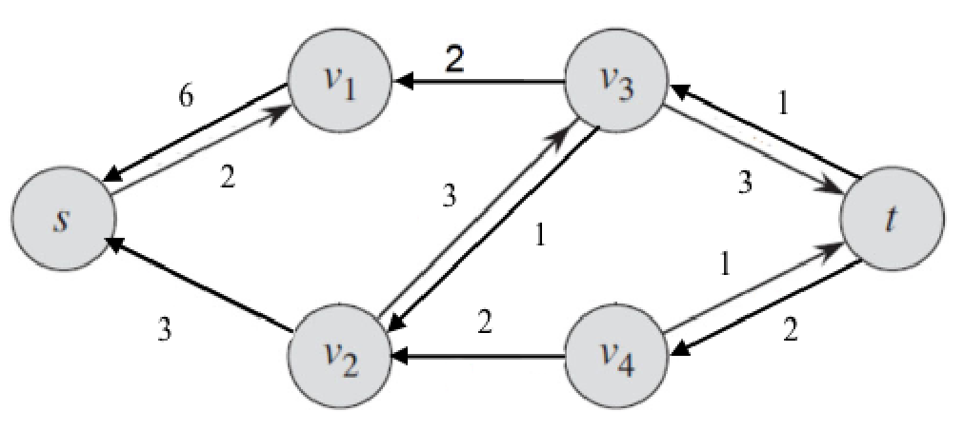

Max flow = 6+3 = **9**

**20’s:** 20 (Rubenstein), 23E (West E), 23H (West H), 24 (Ryder)

**30’s:** 30 (Shillman), 34 (Lake), 38 (Knowles), 39 (Dockser)

**40’s:** 41 (Cabot), 43 (Dodge) ,45 (Gains Garage), 49 (Robinson)

**50’s:** 50 (Curry), 52 (Ell), 57(Dana), 59 (Snell), 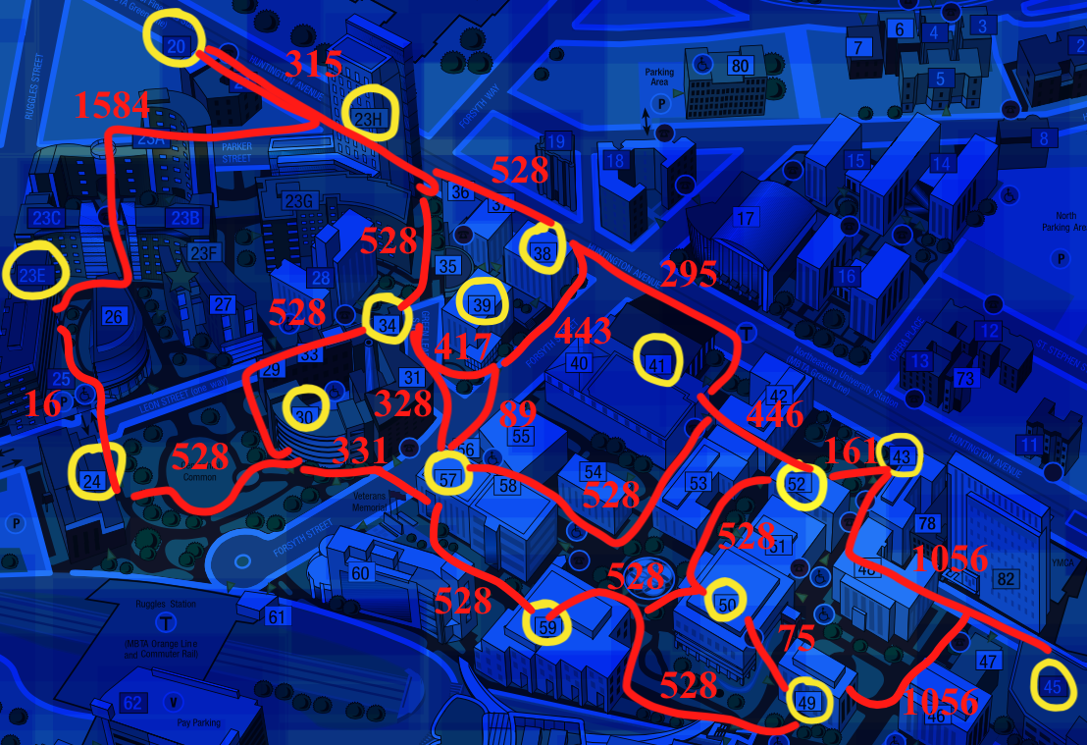

For ease of reading, the following locations are mapped to the following nodes:

20 = 0, 23E = 1, 23H = 2, 24 = 3

30 = 4, 34 = 5, 38 = 6, 39 = 7

41 = 8, 43 = 9, 45 = 10, 49 = 11

50 = 12, 52 = 13, 57 = 14, 59 = 15

**Sample run 1:**

Src = 30 (Shillman)

Dst = 49 (Robinson)

Program Output:

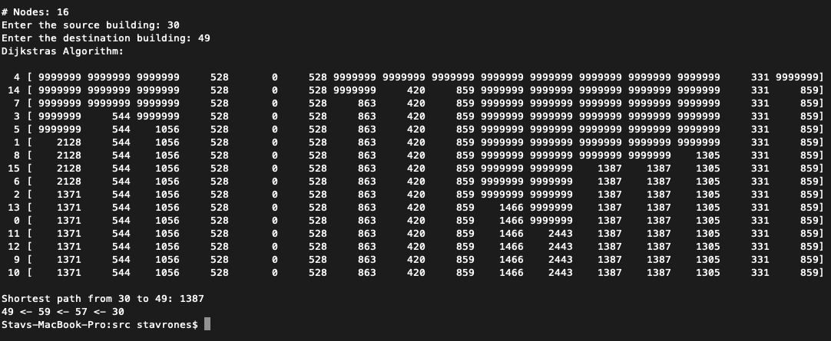

Path trace:

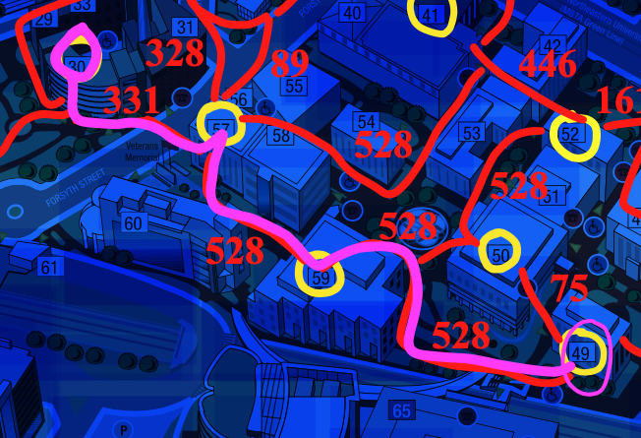

Google maps: (.3 mi = 1584ft $≈1387ft)$ 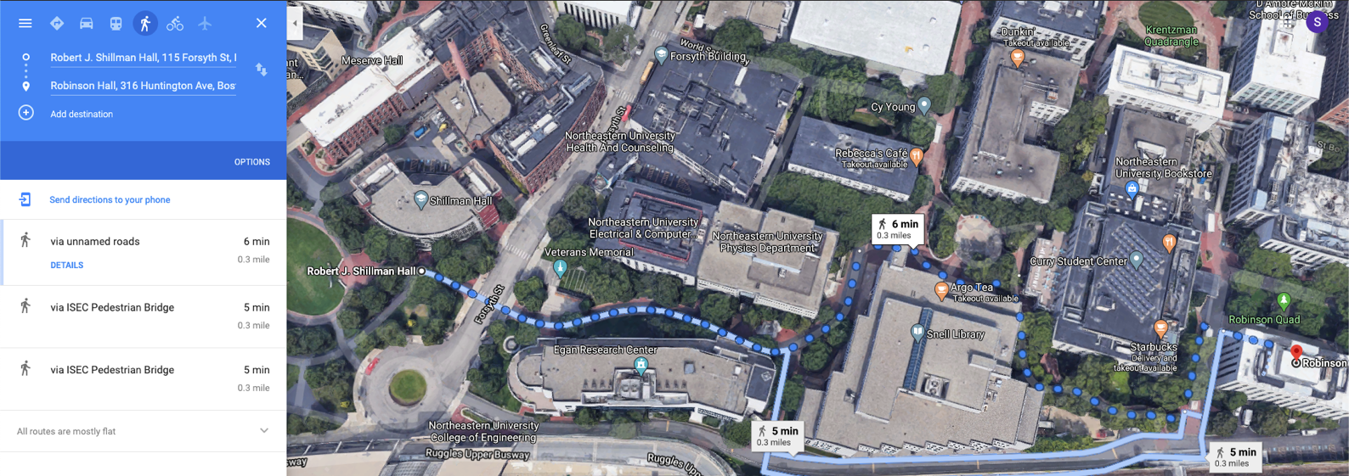

**Sample Run 2:**

Src = 20 (Rubenstein)

Dst = 41 (Cabot)

Program output: 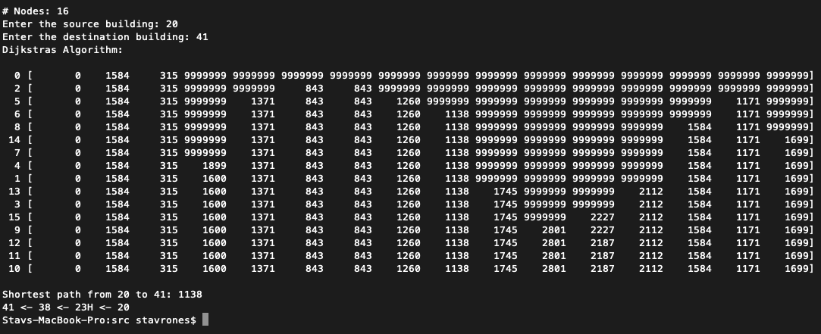

Path trace:

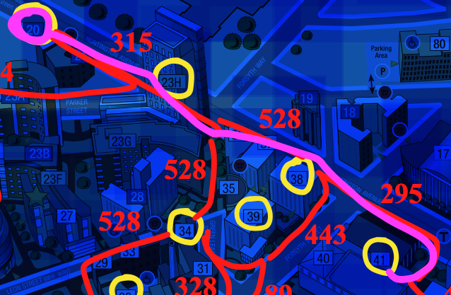

Google maps: (.2 mi = 1056t = approx. 1138)

